**Article Title**

Author A1, Author B1,*, Author C2

1 College of Aerospace Science and Engineering, National University of Defense Technology, Changsha 410073, China

2 State Key Laboratory of Aerodynamics, Mianyang 621000, China

* Correspondence: email address

(For Author names, please use full names, with given names before family names; For affiliations, please include Sub-organization, Organization, City, Post code, and Country.)

**Abstract**

Text for this section ...

**Keywords:** Keyword A, Keyword B, Keyword C ...

(The abstract should briefly summarize the **aim or purpose, methodology, results or findings, and conclusions** of the article. Please minimize the use of abbreviations and do not cite references in the abstract. If needed, cite a reference in the following style: Author(s), Journal abbreviated title, volume number:page range, year (e.g, Author(s), J Comput Phys 315:16-38, 2016). Use **three to ten keywords** representing the main content of the article. Use a comma to separate each word(s).)

**1 Introduction**

Text for this section ... (The Introduction section should explain the background to the article, its aims, a summary of a search of the existing literature and the issue under discussion.)

...

**2 Section Title**

Text for this section ...

**2.1 Sub-heading for Section**

Text for this sub-heading ...

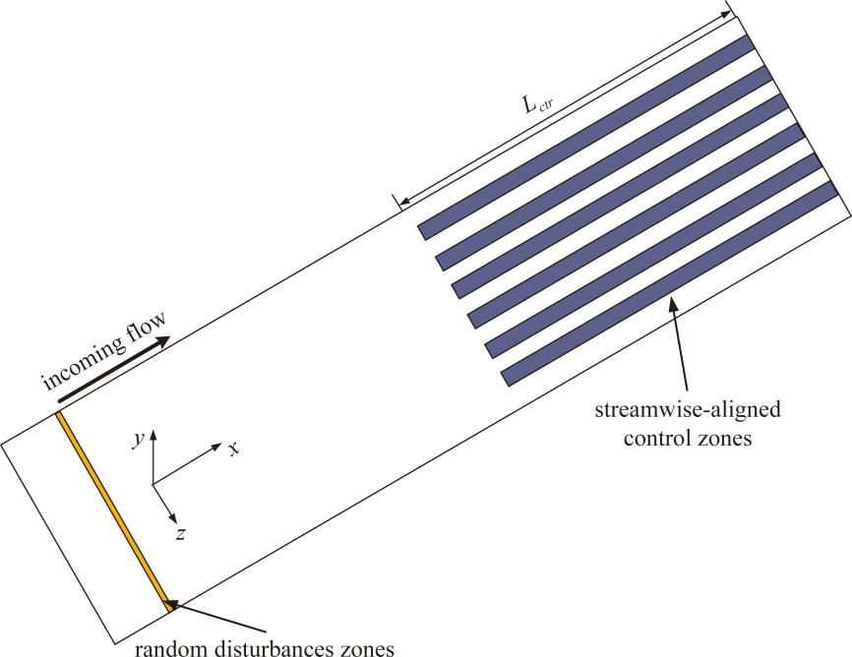

**Fig. 1** Schematic of hypersonic flat-plate with streamwise-aligned control zones (each slot is equidistant from the other)

*2.1.1 Sub-sub heading for section*

Text for this sub-sub-heading ...

**Table 1** Control parameters

|  |  |  |
| --- | --- | --- |
| **Case** | ***Δv*** | ***ΔT*** |
| NC | 0 | 0 |
| B1H1 | 0.1% | 1% |
| B1 | 0.1% | 0 |
| H1 | 0 | 1% |

**2.2 Sub-heading for Section**

Text for this sub-heading ...

*2.2.1 Sub-sub heading for section*

Text for this sub-sub-heading ...

, (1)

where

, ,(2)

*x* is the distance from the leading edge of the flat-plate, and  are respectively the mean viscosity and temperature of wall. ...

|  |  |
| --- | --- |
|  |  |
| (a) NC | (b) B1H1 |

**Fig. 2** Iso-surface of *Q* = 0.2 to visualize vortical structures (colored by streamwise velocity)

*2.2.2 Sub-sub heading for section*

Text for this sub-sub-heading ...

...

**3 Section Title**

Text for this section ...

**3.1 Sub-heading for Section**

Text for this sub-heading ...

*3.1.1 Sub-sub heading for section*

Text for this sub-sub-heading ...

Sub-sub-sub heading for section. Text for this sub-sub-sub-heading ...

...

(The main text should contain the body of the article, and may be broken into subsections with short, informative headings.)

**4 Conclusions**

Text for this Section ... (The Conclusions section should state clearly the main conclusions and include an explanation of their relevance or importance to the field.)

**List of abbreviations** (If abbreviations are used in the text they should be defined in the text at first use, and a list of abbreviations should be provided.)

CFD Computational fluid dynamics

LES Large eddy simulation

DNS Direct numerical simulation

...

**Declarations**

(All manuscripts must contain the following sections under the heading 'Declarations'. If any of the sections are not relevant to your manuscript, please include the heading and write 'Not applicable' for that section.)

**Acknowledgements**

Text for this section ... (Please acknowledge anyone who contributed towards the article who does not meet the criteria for authorship including anyone who provided professional writing services or materials.)

**Authors' contributions**

Text for this section ... All authors read and approved the final manuscript. (The individual contributions of authors to the manuscript should be specified in this section. Please use initials to refer to each author's contribution, for example: "FC analyzed and interpreted.... RH performed ..., and was a major contributor in writing the manuscript."

**Funding**

Text for this section ... (All sources of funding for the research reported should be declared. The funding names and grant numbers should be given.)

**Availability of data and materials**

Text for this section ... (Data availability statements should include information on where data supporting the results reported in the article can be found. For example: “The datasets used and/or analysed during the current study are available from the corresponding author on reasonable request.”)

**Competing interests**

Text for this section ... (All financial and non-financial competing interests must be declared in this section. Please use the authors’ initials to refer to each authors' competing interests. If you do not have any competing interests, please state “The authors declare that they have no competing interests.”)

**Authors’ information (optional)**

Text for this section ... (You may choose to use this section to include any relevant information about the author(s) that may aid the reader's interpretation of the article, and understand the standpoint of the author(s). This may include details about the authors' qualifications, current positions they hold at institutions or societies, or any other relevant background information. Please refer to authors using their initials.)

**References**

(References should be numbered consecutively in the order in which they are first referenced in the manuscript. Examples of reference style are shown below.)

1. Jiang D, Mao M, Li J et al (2019) An implicit parallel UGKS solver for flows covering various regimes. Adv Aerodyn 1:8
2. Cercignani C (2000) Rarefied gas dynamics: from basic concepts to actual calculations. Cambridge University Press, Cambridge
3. ISSN International Centre (2006) The ISSN register. http://www.issn.org. Accessed 20 Feb 2007

**Other Guidelines for preparing and submitting your manuscript**

1. **Main points for preparing figures**

* Figure titles (max 15 words) and legends (max 300 words) should be provided in the main manuscript, not in the graphic file.
* Figures should be included in the main manuscript file.
* Figures should be numbered in the order they are first mentioned in the text, and uploaded in this order.
* Multi-panel figures (those with parts a, b, c, d etc.) should be submitted as a single composite file that contains all parts of the figure.
* Please provide figures with high resolution. Also, please guarantee that a same font is used for texts in the figures throughout the manuscript, and the font size is appropriate.
* Please note that it is the responsibility of the author(s) to obtain permission from the copyright holder to reproduce figures (or tables) that have previously been published elsewhere. In order for all figures to be open access, authors must have permission from the rights holder if they wish to include images that have been published elsewhere in non open access journals. Permission should be indicated in the figure legend, and the original source included in the reference list.

1. **Main points for preparing figures**

* Table titles (max 15 words) should be included above the table, and legends (max 300 words) should be included underneath the table.
* Tables should be included in the main manuscript file.
* Tables should be numbered and cited in the text in sequence using Arabic numerals (i.e. Table 1, Table 2 etc.).
* Tables should not be embedded as figures or spreadsheet files.
* All tables should have the following three horizontal lines: One under the title, above the column headings; One between the column headings and the body of the table; One at the bottom of the table. No vertical lines may be used.
* Color and shading may not be used. Parts of the table can be highlighted using superscript, numbering, lettering, symbols or bold text, the meaning of which should be explained in a table legend.

1. **Main points for submitting manuscript**

* Manuscript should be submitted using the submission and peer-review tracking system Editorial Manager® online: https://www.editorialmanager.com/aiae/default.aspx. File formats such as DOC/DOCX, RTF, TeX/LaTex are acceptable, and editable files are required for processing in production.
* Please guarantee that a complete **Declarations** part is included in the manuscript before submission.
* Please guarantee that the author names, affiliations, email addresses, article title, Abstract and other elements filled in the system are the same as those in the manuscript. Otherwise, the manuscript will not pass the technical check.
* Please declare in the ***Cover Letter*** that the contents in the manuscript, in whole or in part, have not been published or submitted for possible publication in another journal. Also, you are encouraged to provide several recommended reviewers here.

For more detailed Submission Guidelines, please visit the journal’s website: <https://aia.springeropen.com/>

For editorial and submission inquires, please email us at: [aia@cardc.cn](mailto:aia@cardc.cn).

To submit a new manuscript, check the status of a submitted one, or submit a revised manuscript, please go to: <https://www.editorialmanager.com/aiae/default.aspx>.

***Advances in Aerodynamics***

**welcomes**

**your original, high-quality and excellent manuscripts on aerodynamics research.**